WINE MERCHANTS & THE PLANTAGENET TRADE NETWORK
Step 4 : The archive strikes back

Document set A : Legal & economic sources
- What measures encouraged foreign wine merchants to trade in England?
- What evidence shows that the wine trade was economically important?
- Using the three documents, explain why English kings had an interest in protecting wine merchants.

Doc.1 - Privileges granted to foreign merchants in England (1303)

All merchants of the aforementioned lands and kingdoms may, with whatever merchandize they have, come safely and securely into our kingdom of England or any other place under our dominion, under our patronage and protection, exempt from paying murage, pontage, or pavage. Each of them ought to be able to conduct commercial transactions, including wholesale, in cities, boroughs, and market towns within our kingdom. […]
We grant and guarantee those merchants, on our behalf and that of our heirs in perpetuity, that henceforth their wares, merchandize, or other goods, shall not, against their will, be subject to any prise, seizure, or delay […]
All bailiffs and officers of fairs, cities, boroughs, and market towns, when the aforesaid merchants bring complaints before them, do not delay but provide speedy justice according to the law merchant […]
For every tun of wine that they import, or have imported, into our kingdom or dominions, for which they are obliged to pay maritime freight, they shall pay to us or our heirs, by way of customs, two shillings over and above the ancient custom due. […]
Source: Extract from Carta Mercatoria*, 1303.

*Carta Mercatoria is a charter issued by King Edward I of England in 1303. It granted foreign merchants legal protection and trading privileges in exchange for paying customs duties.

Vocabulary box
- Wares / merchandise = goods
- Prise / seizure = confiscation
- Bailiff = local official
- Tun of wine = a large barrel of wine
- Custom = customs duty (tax on trade)

Doc.2 - Total wine exports from Gascony (tuns)
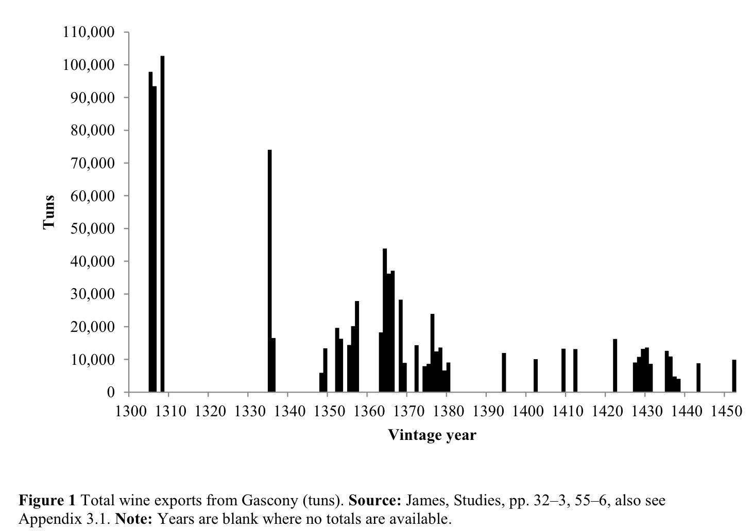
Source : R. Blackmore (2018) "The Political Economy of the Anglo-Gascon Wine Trade, c.1348–c.1453", University of Southampton, Faculty of Humanities, PhD Thesis, 1-217.

Doc.3 - Edward III protects Aquitanian Wine Merchants (1335)

« To all sheriffs, mayors, bailiffs, ministers and the other liege men of the king, and also the collectors of murage, pontage and pavage, both within and without liberties.
Letters of protection and safe and secure conduct granted to Arnaut Jougla, Bidau Duviella, Arnaut [Jougla], son of Arnaut Jougla, Pey Grossemans , Arnaut Blanc, Arnaut-Guilhem Saumier, Sans de Bules , Pey de la Rame and Johan de Lévignac, of Marmande, wine merchants of the duchy [of Aquitaine] coming to the kingdom with their wines and goods, and also their men and servants.
No-one is to damage or harm them, their wines, goods and merchandise, take anything from them against their will, nor presume to disturb them in their liberties contrary to the tenor of their charter. This is provided that they pay all due customs. Therefore it is ordered that Jougla and the other merchants, their men and servants are maintained, protected and defended, and that amends are made for anything that has been forfeited without delay, and that no wine, property or merchandise is to be taken from them for the king's use against their will without due satisfaction being made.
Edward I, amongst various liberties which he granted to them by his charter, which the king has confirmed, granted that the wine merchants of Gascony, and other alien merchants, should be able to come safely and securely into his realm, and should be free from the payment of murage, pontage and pavage everywhere within it, and that no exaction, payment or requisition ( exactio, prisa vel prestatio) should be taken from them for the king's use, just as is more fully contained in the charter and its confirmation. »

Source: Gascon Roll for the 9th year of the reign of Edward III, GSR C61 47, 8 July 1335.
, https://gasconrolls.org/edition/calendars/C61_47/document.html#it047_09_04f_066

Document Set B : Maritime trade: rules, risks and protection
- What risks did merchants face when transporting wine by sea?
- How do the authorities and maritime laws try to reduce these risks?
- Would you say that wine trading was a risky business? Justify your answer using the documents.

Doc.1 - Rules governing the wine trade at sea
The Rôles d'Oléron provides a set of rules that define the rights and obligations of the parties (merchants and shipmasters) to the maritime adventure during the outward voyage of a ship that would have loaded a cargo of wine at La Rochelle or Bordeaux and sailed north to Brittany, Normandy, England, Scotland or Flanders.

Article 2: The master must ask the mariners for their opinion of the weather before setting sail. If he fails to ask their advice, then the master is responsible if the ship and its cargo are lost.
Article 3: If the ship is lost, the mariners must try to save the cargo. If they do their duty, the master must return them to their home port. If they do not do their duty, the master owes them no obligation. The master shall not sell the cargo; he must place it in a safe location.
Article 8: In need, the cargo may be jettisoned overboard; in such event, the permission of the owners of the cargo is required or the master must swear that it was necessary to save the ship.
Article 24: The responsibility of the pilot ends when the ship arrives in the port of moorage.

Source : The Rôles d’Oléron (12th–13th centuries)
https://www.trans-lex.org/116770
Doc.2 - Piracy and the wine trade in Aquitaine (1320)
Three Gascon merchants complained after Irish pirates seized a ship carrying wine from Bordeaux and stole its cargo.
Order to the seneschal of Gascony, or his lieutenant, to hear the complaint of the merchants Bernat Durand, Ramon Rolland and Arnaut de Laroque concerning the taking of a ship carrying their cargo of wine, and do full and speedy justice on the evildoers who seized it and those who knowingly received the ship and the goods from the evildoers whom he is able to find within his jurisdiction, according to the fors and customs of those parts.
The merchants complained that they placed 62 tuns and fourteen pipes of wine in the ship of Pierre Lemarchand called le Gayllard of Breuil-du-Pas at Bordeaux to go to Vannes or Redon to make their profit, but that Michael de Roppe of Waterford , Richard White of Waterford , Ralph Bonny of Youghal , Henry de Windsor , Robert Dennis of Cork , Philip de Cornwall , William Tyrell of Youghal , Gilbert Bernard of Youghal , William Penny of Youghal and certain other evildoers from Ireland boarded the ship in a hostile manner on the river Gironde , between Castillon[-de-Médoc] and Blaye, killed the crew, and took the ship and its cargo, and did what they wanted with it to the grave damage and impoverishment of the merchants, as more plainly appears by the letters patent of the mayor and jurats of Bordeaux under their seal, and the merchants have requested a remedy.
Source: Gascon Roll for the 13th and 14th years of the reign of Edward II, GSR C61 33, 11 August 1320.
https://www.gasconrolls.org/edition/calendars/C61_33/document.html#it033_14_06f_251
Doc.3 - A Bordeaux merchant loses his cargo
King Henry IV grants compensation to a Bordeaux merchant whose goods had been seized during wartime.
Marque granted to Arnaut de Poyanne of the city of Bordeaux, up to a value of 250 m.st. on the enemies' goods, with the proviso that it would be without damage for the king's liege men, the persons being included in the truces and the persons having the king's safeguard, since during the truce, Poyanne having a safe-conduct of the adversary of France, some king’s enemies seized Poyanne’s goods up to this value.
Source : Gascon Roll for the 7th to 8th years of the reign of Henry IV, GSR C61 111, 10 February 1406.
https://gasconrolls.org/edition/calendars/C61_111/document.html#it111_07_11f_019
Vocabulary box
- seized = confiscated
- safe-conduct = official protection for travel and trade
- marque = royal authorization to seek compensation
Document Set C : Geographic & material evidence
- What does the map reveal about the scale of medieval trade networks?
- How was wine transported from Bordeaux to northern Europe? What do the wine casks tell us about the organisation of the wine trade?
- Why was the Vintry district important for the wine trade in London?

Doc. 1 - Map medical trade route

The most important trade routes used by medieval wine merchants
p. 90 - The Wine Trade in Medieval Europe 1000–1500, Susan Rose, 2013.

ou Western European economy 1000–1250

https://www.daviddarling.info/encyclopedia_of_history/W/Western_European_economy_1000-1250.html#google_vignette

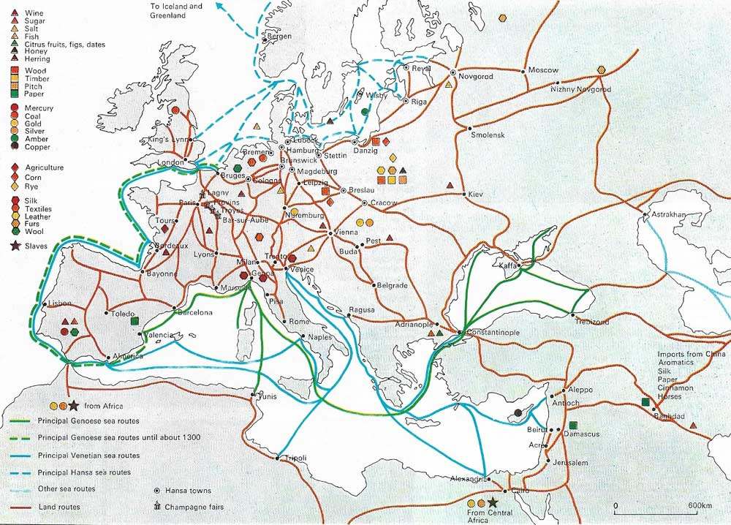

Doc. 2 - English wine cask units

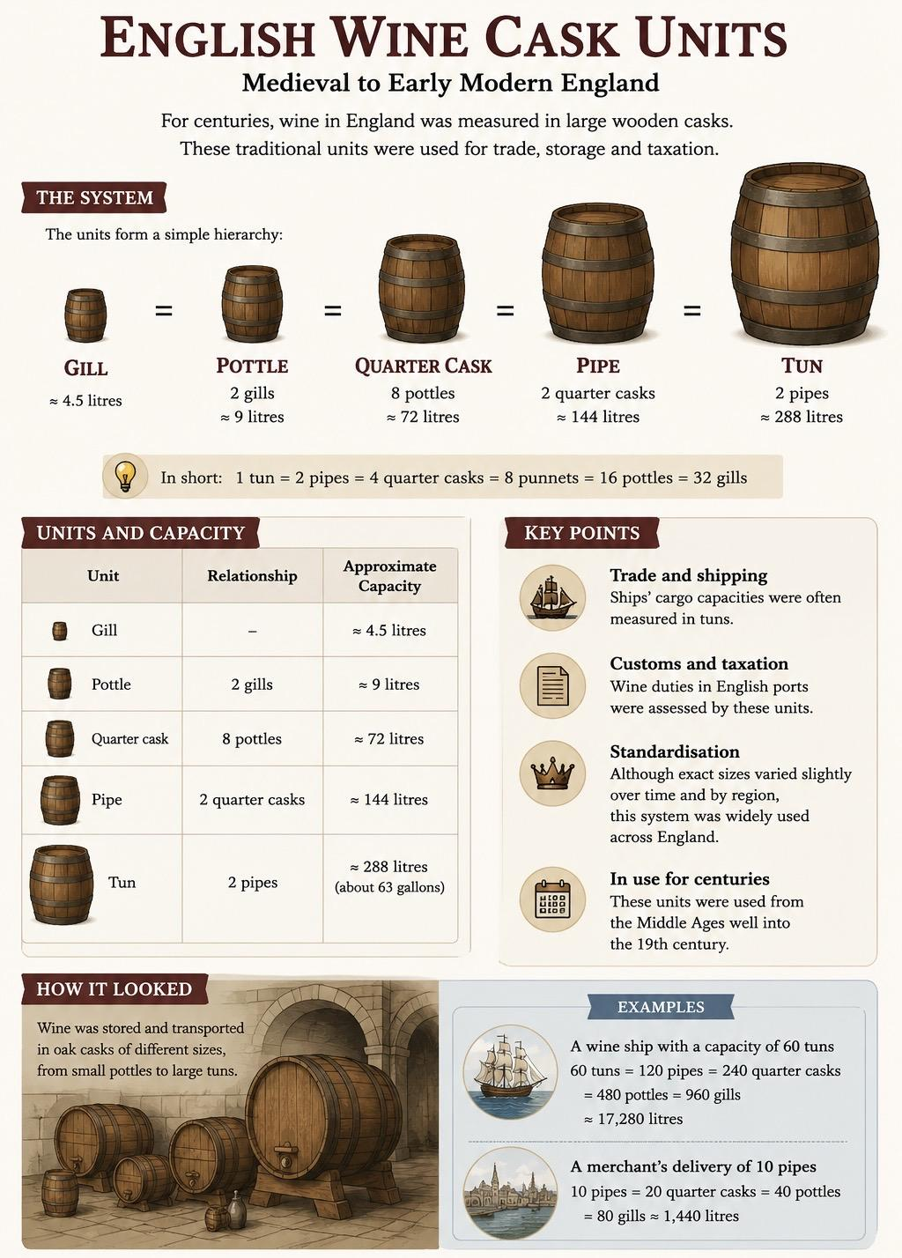
Infographie réalisée par ChatGPT à partir de cette page :
https://en.wikipedia.org/wiki/English_wine_cask_units?utm_source=chatgpt.com

Doc. 3 - Vintry: London’s Wine District

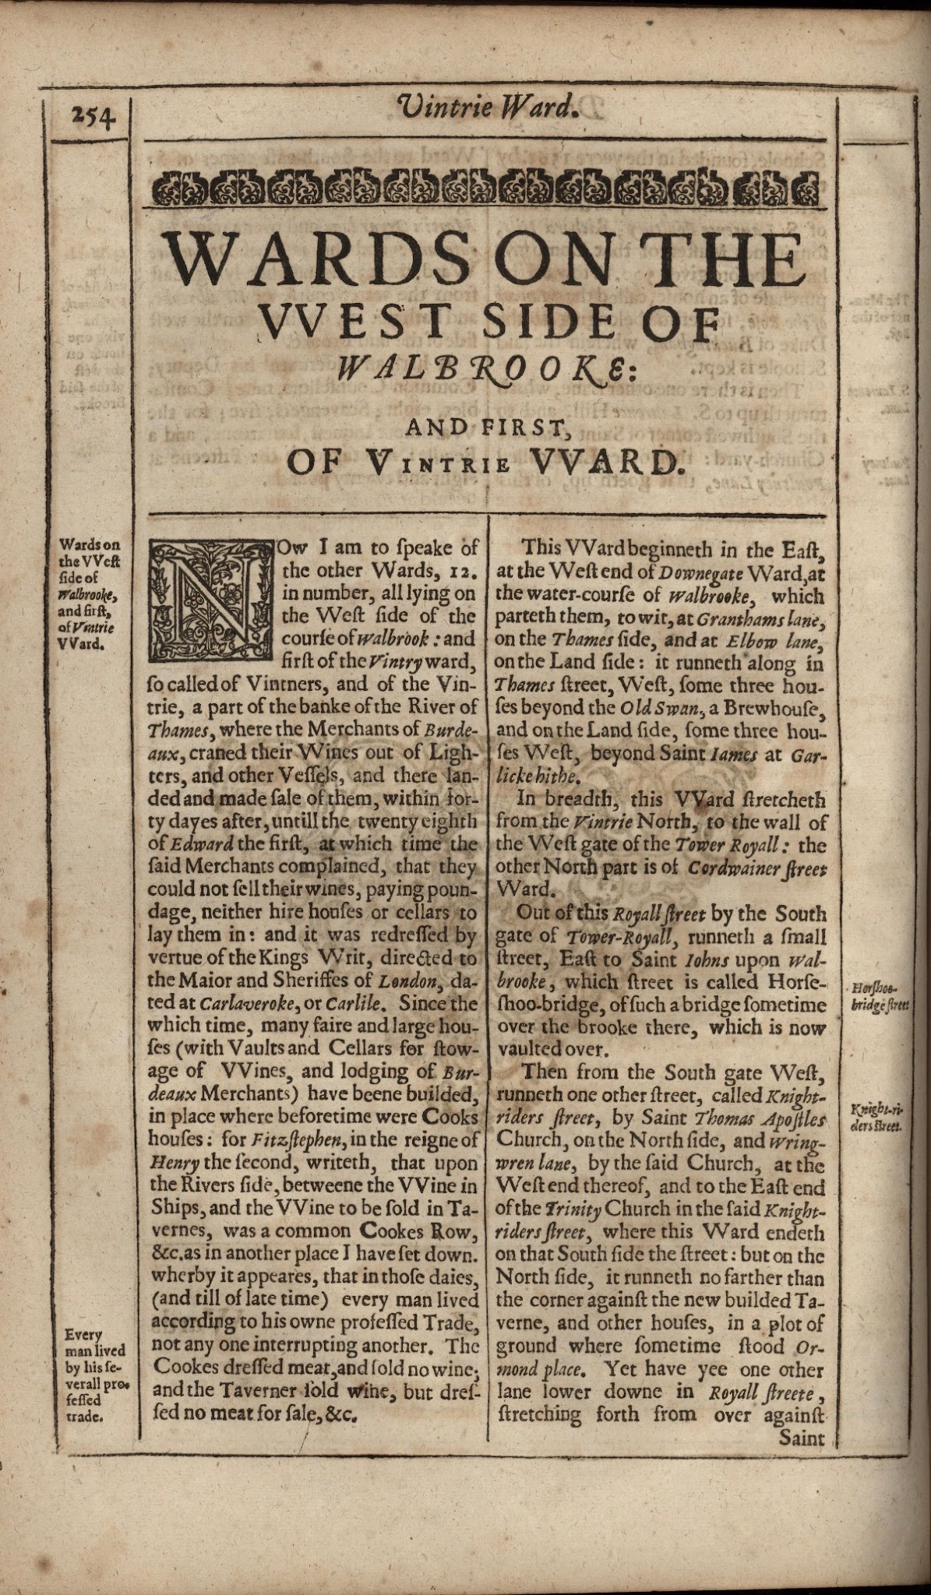 | Now I am to speak of the other Wards, 12. in number, all lying on the West side of the course of Walbrook: and first of the Vintry ward, so called of Vintners, and of the Vintrie, a part of the banke of the River of Thames, where the Merchants of Burdeaux, craned their Wines out of Lighters, and other Vessels, and there landed and made sale of them, within forty dayes after, untill the twenty eighth of Edward the first, at which time the said Merchants complained, that they could not sell their wines, paying poundage, neither hire houses or cellars to lay them in: and it was redressed by vertue of the Kings Writ, directed to the Maior and Sheriffes of London, dated at Carlaveroke, or Carlile. Since the which time, many faire and large houses (with Vaults and Cellars for stowage of VVines, and lodging of Burdeaux Merchants) have beene builded, in place where before time were Cooks houses: for Fitzstephen, in the reigne of Henry the second, writeth, that upon the Rivers side, betweene the VVine in Ships, and the VVine to be sold in Tavernes, was a common Cookes Row, &c. as in another place I have set down. wherby it apeares, that in those daies, (and till of late time) every man lived according to his owne professed Trade, not any one interrupting another. The Cookes dressed meat, and sold no wine; and the Taverner sold wine, but dressed no meat for sale, &c. […]  The Vintners in London were (of old time) called Merchants Vintners of Gascoyne, and so I reade them in the records of Edward the 2. the 11. yeere, and Edward the 3. the ninth yeere, they were as well Englishmen, as strangers borne beyond the Seas, but then subjects to the King of England, great Burdeaux Merchants of Gascoyne and French wines; divers of them were Maiors of this Citie; namely, Ioh. Adrian, Vintner, Reignold at Conduit, Iohn Oxenford, Henry Picard, that feasted the Kings of England, France, Scotland, and Cypres: Ioh Stodie, that gave Stodies lane to the Vintners: which foure last named, were Maiors in the reign of Edward the third, and yet Gascoyne Wines were then to be sold at London, not above 4. pence, nor Rhenish Wines above 6. pence the Gallon.

Source : Stow, John, Anthony Munday, Anthony Munday, and Humphrey Dyson. Survey of London (1633): Vintry Ward. The Map of Early Modern London, Edition 7.0, edited by Janelle Jenstad, U of Victoria, 05 May 2022, mapoflondon.uvic.ca/edition/7.0/stow_1633_VINT2.htm. Draft.

Document Set D : Political context
- How could war disrupt the wine trade between Bordeaux and England?
- How did Bordeaux protect its merchants from competition?
- How did political control help Bordeaux dominate the wine trade?

Doc.1 - War threatens the sea routes between Bordeaux and England

Naval battle of La Rochelle, 1372  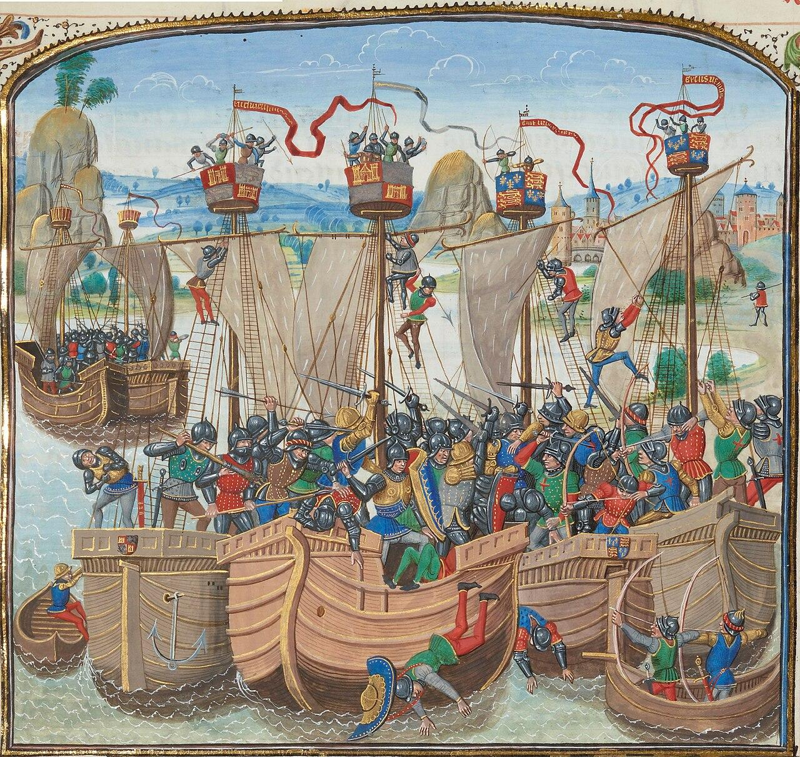  Source : Chronicle of Jean Froissart, XVe, BNF. | The naval battle on 22nd June 1372 in the Hundred Years War between the English and the Castilians which saw the complete destruction of the English fleet and of England’s plans for the defence of Gascony against the French.  The English defeat at the Battle of La Rochelle deprived the Plantagenets of control over a strategic Atlantic port. This event threatened the maritime links between Bordeaux and England, which were essential to the wine trade.

Doc.2 - The Bordeaux wine privilege

The Anglo-Gascon alliance gave Bordeaux the opportunity to establish a legal and fiscal system that protected it from competition and allowed its wine to be sold under the most favorable conditions.
During the thirteenth century, the Lower Country (Bas-Pays) remained firmly loyal to the Anglo-Gascon cause, while the Upper Country (Haut-Pays) had already fallen under the influence of Toulouse and the French Crown. It returned to English allegiance only with the Treaty of Paris in 1259, which became fully effective in 1279 and lasted for just two decades before the French occupation of 1294–1303.
The outbreak of the Hundred Years’ War in the 1340s and 1350s further deepened the divide between territories that had become enemies. Armed conflict was accompanied by a commercial war. Bordeaux’s privileges were officially recognized and strengthened: wines from the Upper Country were no longer allowed to reach Bordeaux before 25 December. This late arrival gave Bordeaux merchants priority access and a monopoly over the lucrative autumn wine fleets.
As a result, trade from the upstream regions was severely disrupted and became increasingly dependent on the decisions of the authorities in Bordeaux.

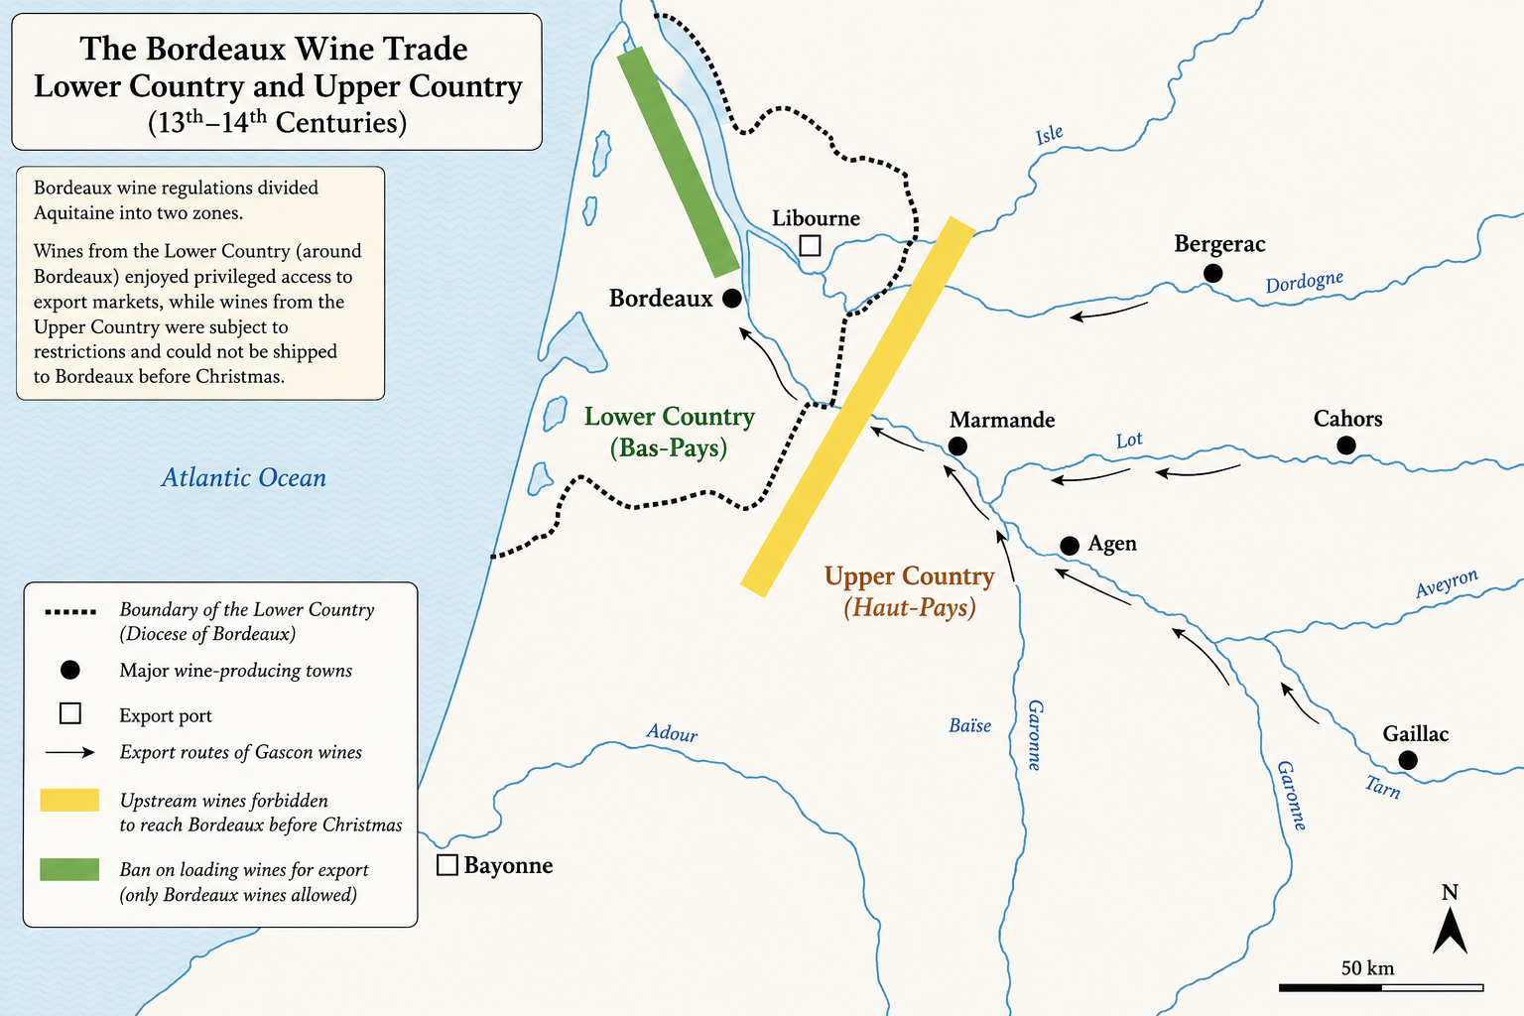

Source : Traduction d’après Lavaud, Sandrine. « Les vins de Bordeaux au Moyen Âge. Entre “protectionnisme de clocher” et grand commerce ». Les petits vignobles, édité par Stéphane Le Bras, Presses universitaires François-Rabelais, 2017, https://doi.org/10.4000/books.pufr.26035.

Doc.3 - The Treaty of Paris : a political agreement that secured English control over Aquitaine and its wine trade

« Know all present and to come, that we, Henry, by the grace of God King of England, Lord of Ireland, and Duke of Aquitaine [...] do grant, quit, and transfer entirely, for ourselves and for our heirs, to the high man and sovereign lord Louis, by the same grace King of France, and to his heirs and successors, all the right, domain, and possession that we had or could have in the city and diocese of Normandy, in the city and diocese of Touraine, of Anjou, and of Maine, and in the city and diocese of Poitiers […].  And the said King of France gives and cedes to us and to our heirs, in exchange for these said concessions, all that he held in lakes, lands, and towns within the three dioceses of Limoges, Périgueux, and Cahors [...]. And likewise, the said King of France promises us that after the death of [Alphonse of Poitiers], if he dies without an heir of his body, the land of the Agenais and the land of Saintonge shall return to us or to our heirs.»  Selected extracts - Treaty of Paris, 1259 | 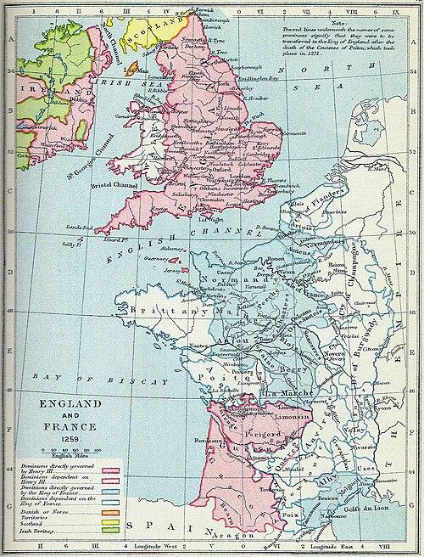  The English Angevin Empire and France after the treaty of Paris.  Source : Gardiner, School Atlas of English History (1892)

