 [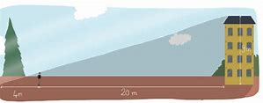](https://www.bing.com/images/search?view=detailV2&ccid=gYkFfxRy&id=716CB7A4031DB4B57E06CD690A06D2E84250EAC0&thid=OIP.gYkFfxRyYr-VVLa2Uao1SQHaC5&q=mod%c3%a9liser+math%c3%a9matiques&simid=607993940400276926&selectedIndex=203)

MODELISER

RAISONNER

[](https://www.bing.com/images/search?view=detailV2&ccid=lTyX4aNj&id=A580311B0375B3A0D904BAA9CF749C93DE327174&thid=OIP.lTyX4aNjn7DKLH0e-PYPlwHaF3&q=communiquer&simid=608009599885116457&selectedIndex=159) [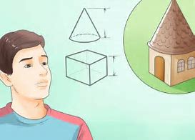](https://www.bing.com/images/search?view=detailV2&ccid=V3aVy4E5&id=86AA178687D1903BAB0ACECA8A4FD832C9A55747&thid=OIP.V3aVy4E5C7RZ1Dfq3_u4fwElDV&q=repr%c3%a9senter+math%c3%a9matiques&simid=607989718467086368&selectedIndex=354)

COMMUNIQUER

REPRESENTER

 [](https://www.bing.com/images/search?view=detailV2&ccid=d42swTHU&id=C2BB57B00B563C2CF141A7D25832944AA361BE34&thid=OIP.d42swTHUTEFXoiLLXw4oKwAAAA&q=calculer&simid=607993833035268637&selectedIndex=95)

CALCULER

CHERCHER