Activity: Election Day in the new Republic!

VOCABULARY (dictionary.cambridge.org)
Democracy: the belief in freedom and equality between people, or a system of government based on this belief, in which power is either held by elected representatives or directly by the people themselves
Republic: a country that is governed by elected representatives and an elected leader
Power: ability to control people and events.
Political power: Power is political when applied to a nation within the framework of a state. There are 3 main political powers:
- Legislature: relating the making of laws
- Executive: the part of a government that is responsible for making certain that laws and decisions are put into action
- Judiciary: relating to the legal system
Political group: an organization of people with particular political beliefs that competes in elections to try to win positions in local or national government
Political institution: It designates a particular element of a political regime. It can be the constitution of a country, the presidency of the republic, the government and its leader, the parliament, laws, regulations, the way in which political life is organised.
Constitution: It is the aggregate of fundamental principles or established precedents that constitute the legal basis of a polity, organisation or other type of entity and commonly determine how that entity is to be governed.
Voting system: Method of voting that determine political representation and structure political life.
Poll: a study in which people are asked for their opinions about a subject or person

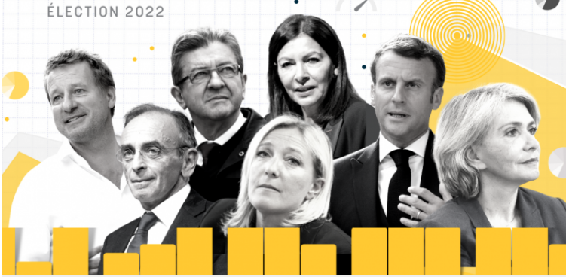

In France there have been be elections to choose the new president in April 2022.

In Champagnistan, the new Republic is coming…. The democratic system is changing, citizens have taken the power to decide the rules of the new political system…

Motto: In champanat we trust !

I- WHAT ARE THE MAIN SPECIFICITIES OF POLITICAL POWER?

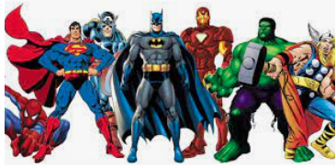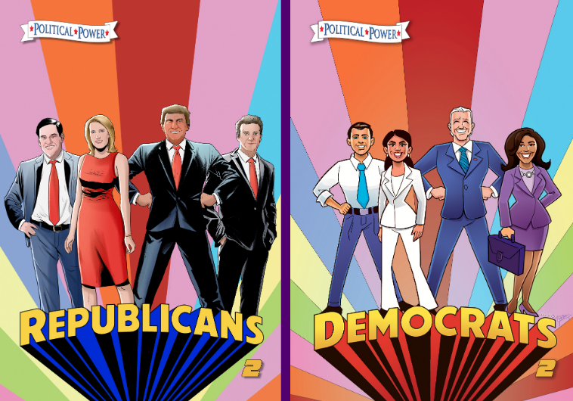
Questions:
1) What kind of power do those people have?
2) What is the origin of their power?
3) How do they use their power?
4) Who have power in those types of government:
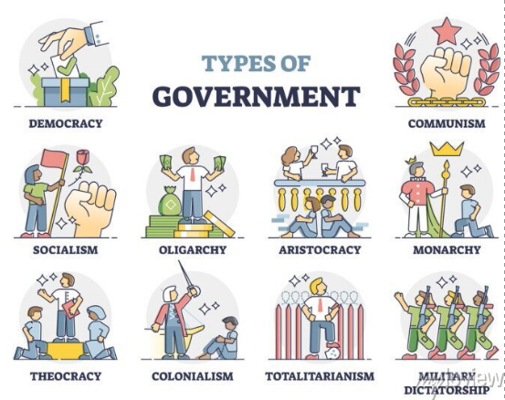

II- WHY SHOULD WE SEPERATE POWERS?

1. Name the 3 political powers: …………………………………………………………………………………………………….…..
2. According to you, should we separate the political powers? Give an answer to this question after watching these videos.
- Separation of Powers explained https://www.youtube.com/watch?v=e1cN5KuB5s0 (2’09)
- What is the Separation of Powers? https://www.youtube.com/watch?v=_882Xztbh5Q (until 1’35)

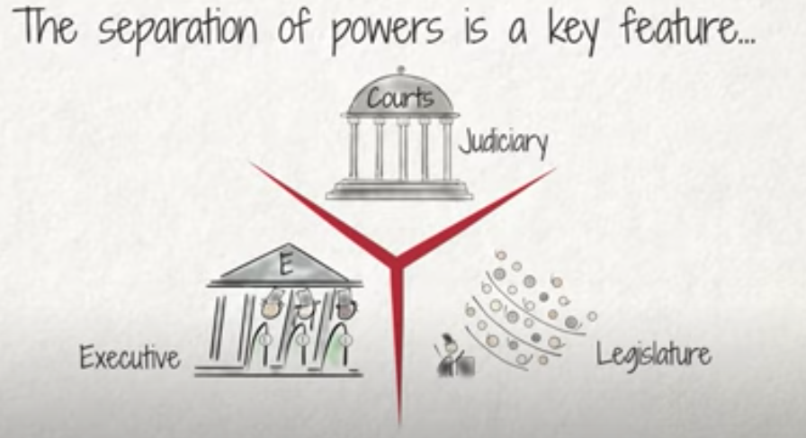
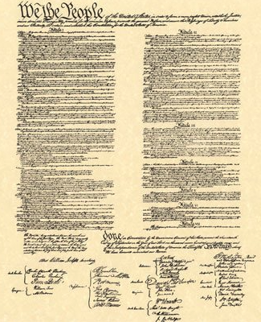
III- WRITE THE CONSTITUTION
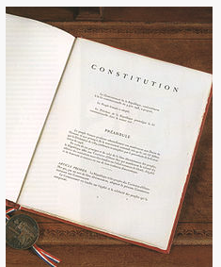

The French constitution (1958)

The Constitution of the United States (1789)

The classification of constitutions by Aristotle:
Now, write the fundamental principles that constitute the legal basis of your country:

We the people of Champagnistan…

IV- ACTIVITY : ORGANIZE ELECTIONS

1. CHOOSE THE VOTING SYSTEM
a) Define how many people are going to have the 3 political powers:
- Executive: …………………………
- Legislature: …………………………
- Judiciary: …………………………
b) Choose between the 2 main methods of voting:
 | Proportional representation  (1 round)  Adapted if you want to choose a group of people. | Election by majority vote  (2 rounds)  Adapted if you want to choose one person.
Executive
Legislature
Judiciary
2. FOUND OF A POLITICAL PARTY
Name your political group
Members
Slogan
Flag
Ideas and values
Main priority (name the most important rule you want to set up as soon as you get the political power)
3. MAKE THE ELECTION CAMPAIGN
Tasks | Advertize your party and ideas! You have to create a poster, a radio spot or make a video…
 | Make a speech (one or several leaders will explain the goal of the party)
Debate.
First, choose in your party who is specialist of each domain.
Then, participate to a debate about this domain.
- Education
- Health Security
- Defense
- Environment
- Culture
- Economy
- Labour
- Justice
- Agriculture

