1. CONSUMPTION : A SOCIAL MARKER?

→ Consumption is a social marker. It will be shown that consumption choices are socially differentiated according to profession, level of education, home, and age. We will examine the influence of fashion and advertising on consumer behavior.

VOCABULARY
Social science : the study of the customs and culture of a society, or a particular part of this subject, such as history, politics, sociology or economics.
Social marker = social act : consumption allows individuals and households to demonstrate their belonging to a social group or their desire to join a social group.
Household : a group of people, often a family, who live together.
A good : a product that is made to be sold.
A service : business activity or act that involves doing things for customers.
Consumption is the act of using, eating, or drinking something. It is the using of goods and services in an economy, or the amount of goods and services used.
A consummer society is a society in which people often buy new goods, especially goods that they do not need, and in which a high value is placed on owning many things.
Fashion is a style that is popular at a particular time, especially in clothes, hair, make-up, etc.
Conspicuous consumption is the situation in which people spend a lot of money intentionally so that other people notice and admire them for their wealth.
Distinction : the quality of being special or different.
Imitation : made to look like something else, it is the act of copying.

Introduction : US Black Friday and China’s Singles’ Day

Video : https://www.youtube.com/watch?v=MW4d8_LLYp8
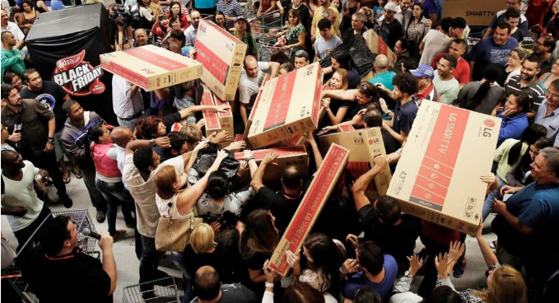
1. What is the « Black Friday »?
…………………………………………………………………………………………………………………………………………………………………………………………………………………………………………………………………………………………………………

2. Describe people’s behaviors in the video. What do you think of it?

3. Do you know what is the « Singles’ day»? Read the texte on the next page and compare to the Black Friday.
…………………………………………………………………………………
…………………………………………………………………………………
……………………………………………………………………………...…
…………………………………………………………………………………
…………………………………………………………………………………
…………………………………………………………………………………

Document 1 : What is Singles' Day?
Singles' Day is a holiday celebrated in China on November 11. Unmarried people commemorate the occasion by treating themselves to gifts and presents, leading Singles' Day to become the largest online shopping day in the world, by quite some margin.

Understanding Singles' Day
Singles' Day always falls on November 11 because the date 11/11 represents four ones, or four singles, standing together. The name literally translates as "single sticks holiday."
Originally called "Bachelor's Day," the celebration began among students at China's Nanjing University around 1993 as a sort of anti-Valentine's Day. The most widely accepted theory is that four male students of Nanjing University's Mingcaowuzhu dorm ("all single men") discussed how they could break away from the monotony of having no significant other, and agreed that November 11 would be a day of events and celebrations in honor of being single. These activities spread through the university and eventually to other universities, appealing to both men and women—hence the name change.
Interestingly, Singles' Day now serves as an occasion for single people to meet, with parties and other social gatherings organized; it's a popular date for weddings as well. On the date, the Chinese media discusses and covers love-related issues and relationship topics.
Singles' Day has since caught on in other countries. It is now celebrated throughout Southeast Asia and some European countries, including Germany, Belgium, and the United Kingdom.

Special Considerations
Although not an officially recognized public holiday in China, Singles' Day has become the largest online shopping day in the world. The holiday became a major commercial event in China during the first decade of the 21st century when Chinese e-commerce giant Alibaba offered deeply discounted merchandise on its platform for 24 hours, starting at midnight on Nov. 11, 2009.
Since then, Singles' Day has become a super shopping day, similar to the post-Thanksgiving Black Friday and Cyber Monday in the U.S. In 2019, Alibaba registered $38.4 billion worth of sales across its online platforms on Singles’ Day, representing a rate of 25% from the previous year's $30.8 billion.
Fast Fact: China’s Singles' Day is by far the biggest day for internet commerce, easily surpassing the combined sales tallies of both Black Friday and Cyber Monday.

DANIEL LIBERTO, November 11, 2020, https://www.investopedia.com/terms/s/singles-day.asp

ACTIVITY: Discuss in groups on the purposes of consumption.

→ You are at a family dinner and you try to convice your parents that you need a new phone (the Iphone 13 for instance).
2 students play the role of the parents (who disagree!) and 2 students play the brothers/sisters partners to convince their parents.
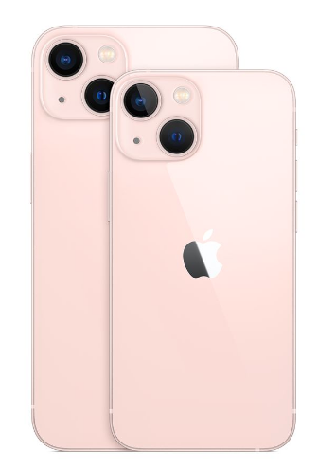
Find arguments that explain the purpose of having a new phone (to answer to a primary need, to join a social group, to make friends, to show-off…) or not (for economical reasons, because it’s useless, it doesn’t make happy…)

Iphone 13 Pro Max 1 To -1839€
A. Why consumption choices are socially differentiated?
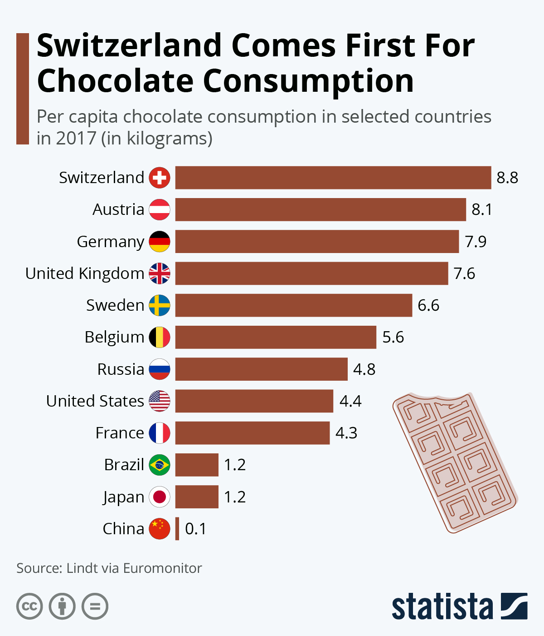
Document 2 : Global chocolate consumption per capita* in 2017, by country
*Per capita : par habitant

1. Do you like chocolate J ?

2. Which inhabitants are the highest chocolate consumers?
………………………………………………………………………………………………………………………………………………………………………………………………………………………………………………………………………………………………………………………………………………………………

3. Could you explain the differences between those countries?
………………………………………………………………………………………………………………………………………………………………………………………………………………………………………………………………………………………………………………………………………………………………………………………………………………………………………………………………………………………………………………………………………………………………

4. On the map below you will find the top 10 cocoa producing countries. Are they the same countries where people eat chocolate and produce cocoa? Explain why.
………………………………………………………………………………………………………………………………………………………………………………………………………………………………………………………………………………………………………………………………………………………………………………………………………………………………………………………………………………………………………………………………………………………………………………………………………………………………………………………………………………………………………………………………………………………………………………………………………………………………………………………………………………………………………………………………………………

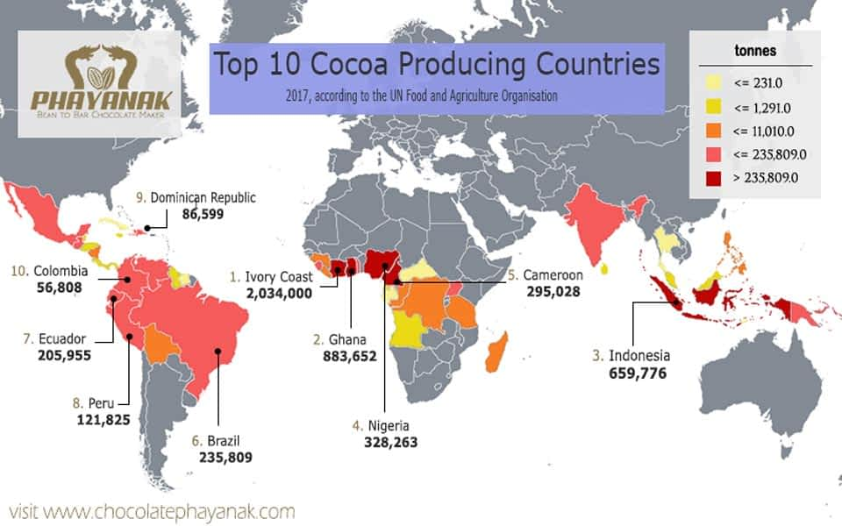
Document 3 : Cultural practices according to standard of living (unit : %)
 | The poorest 20% | The richest 20% | Total population
Cinema
Has been to the movies more than 3 times in a year | 17 | 42 | 28
Couldn't afford to go to the movies in a year | 17 | 1 | 6
Show (theater, concert, live performance)
Has seen a show more than 3 times in a year | 10 | 31 | 18
Couldn't afford to go see a show over a year | 17 | 1 | 6
Cultural site
Visited a cultural site more than 3 times in a year | 11 | 39 | 20
Could not afford to visit a cultural site over a year | 14 | 1 | 5

Source : Insee – Données 2015 – © Observatoire des inégalités

1. Choose a data and make a sentence with it.
………………………………………………………………………………………………………………………………………………………………………………………………………………………………………………………………………………………………………………………………………………………………………………………………………………………………………………………………………
2. Compare the cultural practices differentiated by income.
………………………………………………………………………………………………………………………………………………………………………………………………………………………………………………………………………………………………………………………………………………………………………………………………………………………………………………………………………
3. Discuss. What do you think of this differences? (they are strong, low, normal, scandalous…)

4. Exercice: Complete this text that explain the diferences in the cultural practices with the proposed words : Diploma ; social environment ; studies ; cultural practices ; democratization ; family ; qualification
Many factors combine to explain ………………………………………………………. Among them, the ……………………………………………………… is central. Because you have to put your hand in your wallet most often, but also because of the influence of the people you live with, your ……………………………………………………… origins or your ………………………………………………………. Those who used to visit museums as a child are much more familiar with these often intimidating places. Same for those who had access to the keys to understanding art (the history of the creator, his work, the historical context, etc.) during their ………………………………………………………. Again, this should not be seen as an implacable mechanism: the rise in the level of ……………………………………………………… plays in the direction of the ……………………………………………………… of practices.

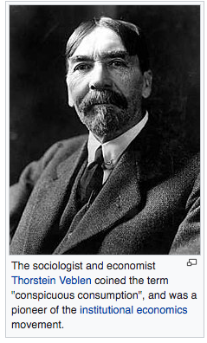
B. Are fashion and advertising really influent?

Document 4: What is conspicuous consumption?
Conspicuous consumption is a term used to describe and explain the consumer practice of purchasing or using goods of a higher quality or in greater quantity than might be considered necessary in practical terms. More specifically, it refers to the spending of money on or the acquiring of luxury goods and services in order to publicly (i.e., conspicuously) display the economic power of one's income or accumulated wealth. To the conspicuous consumer, such a public display of discretionary economic power is a means of either attaining or maintaining a given social status.
Source: Wikipedia
+ Video: Thorstein Veblen and the Leisure Class https://www.youtube.com/watch?v=5T7JkwJxgjo

1. Why those two pictures illustrate conspicuous consumption?
………………………………………………………………………………………………………………………………………………………………………………………………………………………………………………………………………………………………………………
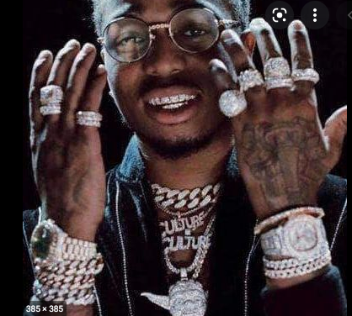
Le rappeur américain Quavo montre sa collection de bijoux.

En mai 2017, Vertu sort une nouvelle version du Cobra pour 320 000 euros. Le téléphone consiste en un Nokia 3310 recouvert de 439 rubis et de 2 émeraudes, et une option de se le faire livrer par hélicoptère.

2. Find other examples of conspicuous consuption.
………………………………………………………………………………………………………………………………………………………………………………………………………………………………………………………………………………………………………………

Document 5: What is fashion ?
Dressing is not about freely associating elements drawn from an infinite number of possibilities, but rather combining elements collected according to certain rules, in a limited reservoir. (…)

Fashion occupies a central place in our lives because it allows us to define our social identity. Yet despite this familiarity, it strikes us as elusive and mysterious. This book aims to lift the veil on the mysteries of the fashion industry. He adopts a sociological point of view but does not ignore the contributions of economics, geography or history. Because of its complexity, fashion requires a multidisciplinary approach.

http://ses.ens-lyon.fr/les-fiches-de-lecture/sociologie-de-la-mode-99932

1. Explain the underlined sentence.
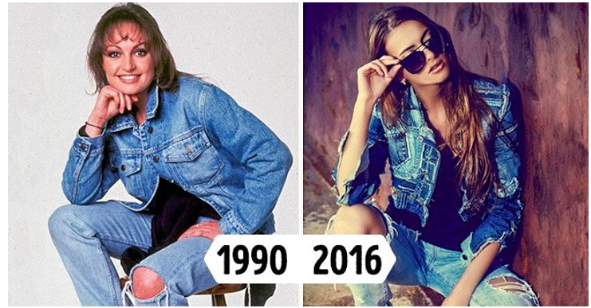
………………………………………………………………………………………………………………………………………………………………………………………………………………………………………………………………………………………………………………
2. Discuss. Fashion, is it imitate and follow the trend or is it distinguish itself and being different?

ACTIVITY : Make your own ad!

1. With your group (2-3 students), invent a brand or a product. It can be a good or a service (be creativ!).

2. Choose the way you are going to promote it (video or radio).

3. Make your ad.

4. Show it to the class and explain:
- The name of your company, the slogan, the product…
- Your choices about the ad, your strategy.
- The type customer you aim (age, sex, socio-professional category) and how you what to reach and influence them.

RECAP : CONSUMPTION : A SOCIAL MARKER?

What do our consumption choices depend on?

• Consumption enables the various economic agents (households, but also businesses or administrations) to satisfy a certain number of needs.
It depends first of all on the income of consumers and the price of the goods or services offered for consumption.

• But if these are two essential criteria, they are not alone:
- social or demographic factors also determine our consumption behavior. Thus, the norms related to the social environment, to the family, participate in the determination of purchasing behavior (spending priorities, for example);
- similarly, age, sex, socio-professional category, type of studies make it possible to describe and explain a number of consumption behaviors. For example, for equal income, household consumption is not the same between a young single person under 30 and a person over 60.

Consumption is a social act.

• Consumption is a social act: it allows individuals and households to demonstrate their belonging to a social group or their desire to join a social group.
This is why an act of consumption can be the manifestation of a desire to imitate a model social group (this is the effect of imitation); it can also be the translation of a desire to distinguish oneself from others, for example to stand out by affirming one's belonging to a social group higher than one's own. This is referred to as the effect of distinction; this can then result in conspicuous consumption, the aim of which is to show others the superiority of one's own position.

• Consumption is subject to many influences, including that of producers of goods and services through advertising. Advertising strategies play on the mechanisms of imitation or distinction to influence consumers, whose freedom is in fact more framed and more limited than they feel.
We call a consumer society the society that wants to create ever more needs on the part of consumers, through advertising or the marketing of new goods and services.
