INTRODUCTION TO SOCIAL SCIENCES

VIDEO : An Animated Introduction to Social Science
https://www.youtube.com/watch?v=DSIdaTSG2Gg

1. Watch the video and write which disciplines do the 5 characters below represent? (Notice the label they have on them)
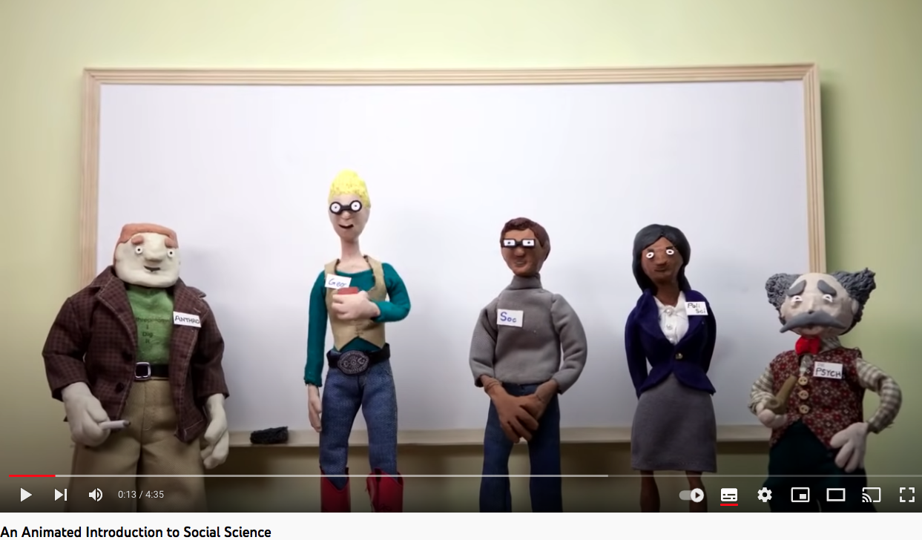

3. Do you know other scientific disciplines in social science ?
………………………………………………………………………………………………………………………………………………………………………………………………………………………………………………………………………………………………………………………………………………………………………………………………………………………………………………………………………
2. According to the end of the video, what do they all study ?
………………………………………………………………………………………………………………………………………………………………………………………………………………………………………………………………………………………………………………………………………………………………………………………………………………………………………………………………………

Going further! Youtube channels to discover sociology, economics and political science :

- Qu'est-ce que la sociologie ? Crash Course Sociologie #1
https://www.youtube.com/watch?v=YnCJU6PaCio&t=48s
- Crash Course Economics Intro!
https://www.youtube.com/watch?v=9I_-ADGrKQo&list=PL8dPuuaLjXtPNZwz5_o_5uirJ8gQXnhEO
- An introduction to the discipline of Politics
https://www.youtube.com/watch?v=YzIcWW3FWSQ

Activity

1. Read the text below :

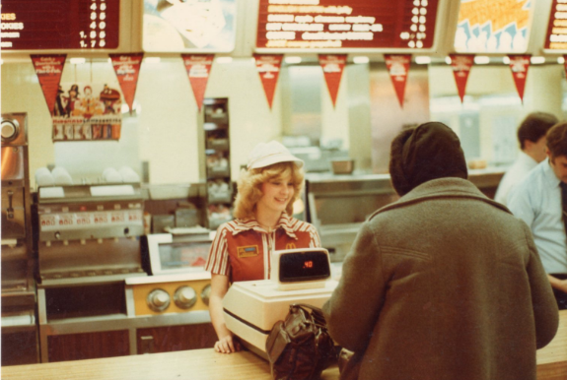
Are there rules for eating at McDonald’s? Generally, we do not think about rules in a fast food restaurant, but if you look around one on a typical weekday, you will see people acting as if they were trained for the role of fast food customer. They stand in line, pick items from the colorful menus, swipe debit cards to pay, and wait to collect trays of food. After a quick meal, customers wad up¹ their paper wrappers and toss² them into garbage cans. Customers’ movement through this fast food routine is orderly and predictable, even if no rules are posted and no officials direct the process.

People have written entire books analyzing the significance of fast food customs. They examine the extensive, detailed physicality of fast food: the food itself, wrappers, bags, trays, those tiny ketchup packets, the tables and chairs, and even the restaurant building. Everything about a chain restaurant reflects culture, the beliefs and behaviors that a social group shares. Sociological analysis can be applied to every expression of culture, from sporting events to holidays, from education to transportation, from fashion to etiquette³.

(…) you'll examine culture and society and come to understand that a culture represents the beliefs, practices and artifacts of a group, while society represents the social structures and organization of the people who share those beliefs and practices.

https://www.coursehero.com/study-guides/wmopen-introtosociology/cultural-similarities-and-differences/

¹ mettre en boule leurs papiers, ² jeter , ³ usage, convenance

2. Explain the underlined sentence.
………………………………………………………………………………………………………………………………………………………………………………………………………………………………………………………………………………………………………………………………………………………………………………………………………………………………………………………………………
3. Have you noticed similar customs (= habitudes) in another situation? (Notice the examples given in the text and try to find others)
………………………………………………………………………………………………………………………………………………………………………………………………………………………………………………………………………………………………………………………………………………………………………………………………………………………………………………………………………
4. According to you, how do people learn to behave (se comporter) in society?
………………………………………………………………………………………………………………………………………………………………………………………………………………………………………………………………………………………………………………………………………………………………………………………………………………………………………………………………………

